Tb and Rb:
Tb is called the bit period. The bitrate or number of bit per second is Rb which is equal to Rb = 1/Tb.
BER:
The fraction of all bits that are in error is called the bit error rate or BER. BER is the same as the probability that a given bit will be in error which will write as Pe.
Power and bandwidth efficiency:
Q1: how much RF bandwidth is required to communicate with the bitrate RB. A modulation scheme that uses less RF bandwidth is said to be more bandwidth efficient.
Q2: what receive power level is required to achieve a given Bit error rate. A modulation scheme that requires less power is said to be more power-efficient.
weather power or bandwidth efficiency is more important depends on our application.
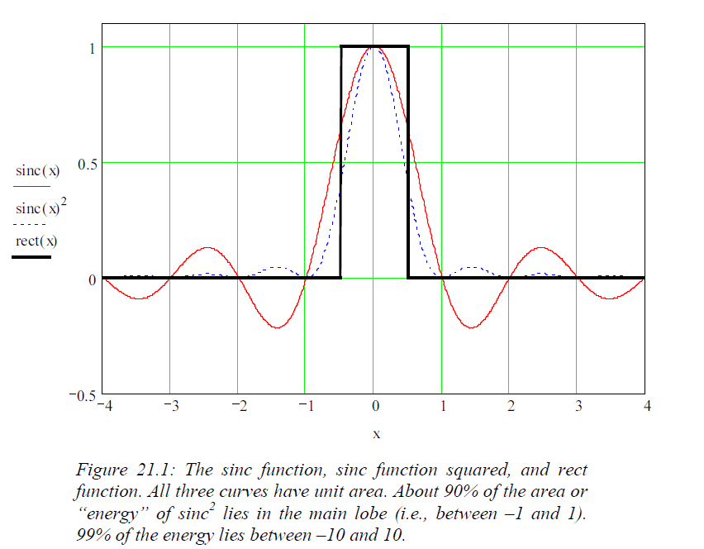
Sinc Function:
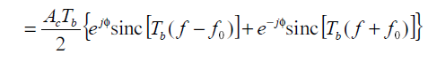

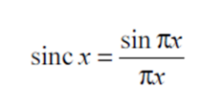
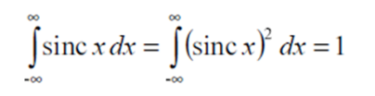

The sinc power in frequency range from (-1/Tb to 1/Tb) around center frequency of fc in 90% of whole power, therefore we will often say that the sink function has a bandwidth equal to BW_{3dB} = 1/Tb which is around (-1/0.5*Tb to 1/0.5*Tb) around center frequency of fc
the bandwidth is equal to the bit rate. (BW_{3dB} = 1/Tb = Rb)
The spectrum is centered at the carrier frequency fc or it's negative.
Eb: (bit energy)
A sinewave modulated pulse has average power of Ac²/2 during the time Tb Bit Energy for this pulse is:
N₀: (Noise spectral density)
if a receiver has noise temperature T_{N} then the noise spectral density N₀ is equal to N₀ = K.T_{N} with K = Boltzmann constant. if the received signal bandwidth is B then the noise power is P_{N} = N₀ B = <n(t)²> in reference resistor where n(t) is the noise voltage as a function of time.
FSK Modulation:
BER for Coherent FSK:
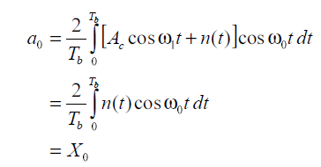
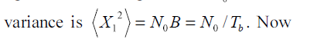
For single section of a receiver the noise voltage variance is σ² = N₀.B = N₀ /T_{b}.
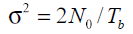
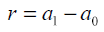
For final FSK output: variance would be twice
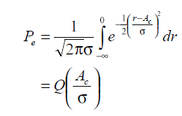
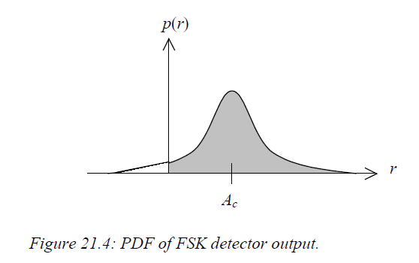


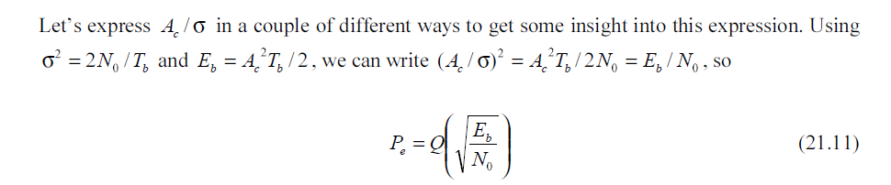

BER for Non-Coherent FSK:
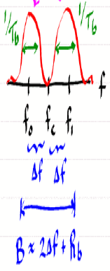
FSK Spectrum:
$\left(f_{1}+f_{0}\right)≫1/T_{b}$ and
$2×T_{b}×\left(f_{1}-f_{0}\right)=n$
$for n=1 {\left(f_{1}-f_{0}\right)}_{min} called \left(MSK\right)→ \left(f_{1}-f_{0}\right)=\frac{1}{{2∙T}_{b}}→∆f= \frac{1}{{4∙T}_{b}}$
$B=2×∆f+\frac{1}{T_{b}}=\frac{1}{{2∙T}_{b}}+\frac{1}{T_{b}}=\frac{3R_{b}}{2}$
MSK:
MSK is FSK with minimum $∆f$ .
For MSK:
$$n=1 {→\left(f_{1}-f_{0}\right)}_{min}$$
$2×T_{b}×\left(f_{1}-f_{0}\right)=n=1$ $\left(f_{1}-f_{0}\right)=\frac{1}{{2∙T}_{b}}→∆f= \frac{1}{{4∙T}_{b}}$
$B=B_{RF}={BW}_{RF}=2×∆f+\frac{1}{T_{b}}=\frac{1}{{2∙T}_{b}}+\frac{1}{T_{b}}=\frac{3R_{b}}{2}$
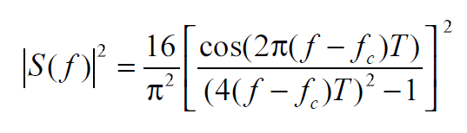
MSK PSD:
Dropped by 1/f ⁴

GMSK:
For GMSK modulation smaller Alpha results in larger bandwidth.
GMSK modulation provides smaller bandwidth and higher Spectrum efficiency however it provides ISI error which needs higher SNR and reduce the power efficiency.
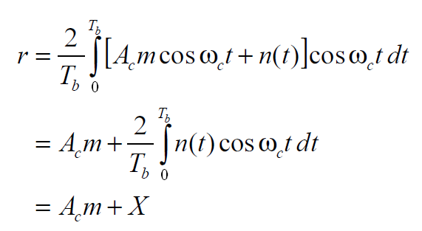
BPSK Demodulation:

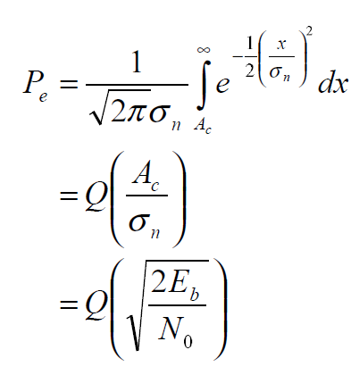
and $σ_{n}^{2}=\frac{N_{0}}{T_{b}}$

Here for BPSK we get an additional factor of 2 compare to FSK. This means that with half the power BPSK can give the same bit error rate as FSK. Therefore BPSK is more power efficient than FSK. In fact we can say it is a factor of two or 3db more efficient.
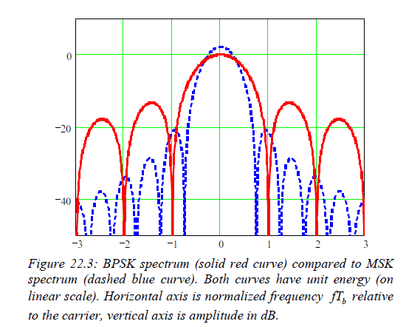
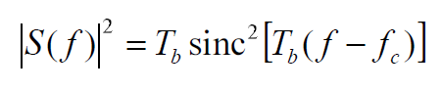
BPSK Spectrum:

For BPSK
$$B_{RF}{=BW}_{RF}=\frac{1}{T_{b}}+\frac{1}{T_{b}}=\frac{2}{T_{b}}=2R_{b}$$

BW Efficiency:
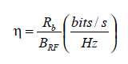

$η_{BPSK}=0.5 and η_{FSK}=0.67$

Filtering BPSK to reduce the side lobe effect causes change in pulse shape more sensitive to nonlinear amplifier and causes spectral regrowth compared to FSK which has no filtering constant amplitude.

QPSK:
in QPSK each symbol represents 2 bits.
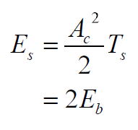
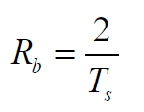
And

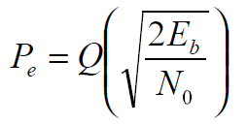
Since qpsk consists of two independent bpsk channels the BER will be identical to the bpsk BER .
Power efficiency of bpsk and qpsk are identical.
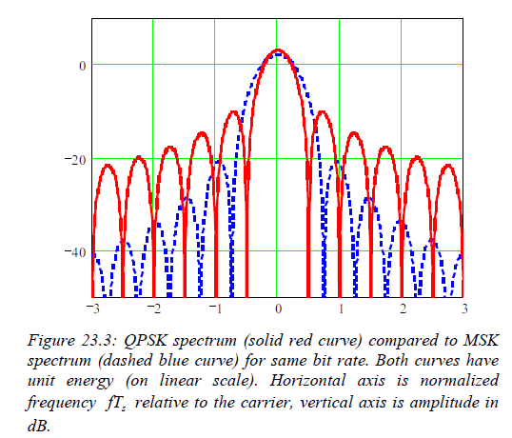
with regard to the Spectrum we have 2 orthogonal BPSK signals at the same carrier frequency however since two bits are sent per symbol the symbol rate need only be one have off the bit rate so :

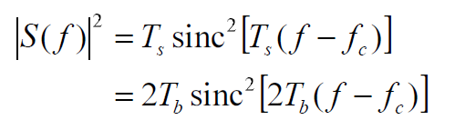

Therefore, the QPSK spectrum is identical to BPSK spectrum but 1/2 the width.
$η_{QPSK}=1 and η_{BPSK}=0.5$
QAM:
With regard to the spectrum we have M orthogonal BPSK signals at the same carrier frequency with different amplitude.
Therefore, the QPSK spectrum is identical to BPSK spectrum but 1/M the width.
In general for M-bit modulation: (For M = 1 bit E_{s} = E_{b} and T_{s} = T_{b})
$σ_{n}^{2}=N_{0}B=\frac{N_{0}}{T_{s}}$
and $$P_{s}= 〈s^{2}〉=\frac{1}{2}×\frac{\sum_{i=1}^{M}{A_{C,i}^{2}}}{M}=\frac{E_{s}}{T_{s}}=\frac{{M×E}_{b}}{T_{s}}$$
$$η_{QAM}=\frac{M}{2} when M=number of bit per symbol$$
$$BER=\frac{Average error direction}{M\left(number of bit per symbol\right)}×Q\left(\frac{a}{σ_{n}}\right) ,$$
$σ_{n}^{2}=N_{0}B=\frac{N_{0}}{T_{s}}$ , $a= \frac{1}{2}d=half of distance between two adjucent points$
$$P_{s}= 〈s^{2}〉=\frac{1}{2}×\frac{\sum_{i=1}^{M}{A_{C,i}^{2}}}{M}=\frac{E_{s}}{T_{s}}=\frac{{M×E}_{b}}{T_{s}}$$
$$and A_{c}=distance from origin to constellation points in terms of a$$
For M=4 (QAM 16)
$$a=\sqrt{\frac{P_{s}}{5}} and σ_{n}^{}=\sqrt{\frac{N_{0}}{T_{s}}} and { P}_{s}×T_{s}=E_{s}={4∙E}_{b}→$$
$BER=\frac{3}{4}×Q\left(\frac{a}{σ_{n}}\right)$ $BER=\frac{3}{4}×Q\left(\sqrt{\frac{4}{5}∙\frac{E_{b}}{N_{0}}}\right)$

